MUSIC APP

# **AIM**

TO DESIGN A MUSIC APP

# **PROCEDURE**

CREATE A GROUP

CREATE A BASIC IDEA OF THE APP OR WEBSITE

SELECT THE NUMBER OF FRAMES

DESIGN THE APP

DO THE PROTOTYPING

EXECUTE THE APP OR WEBSITE

## SCREENSHOT

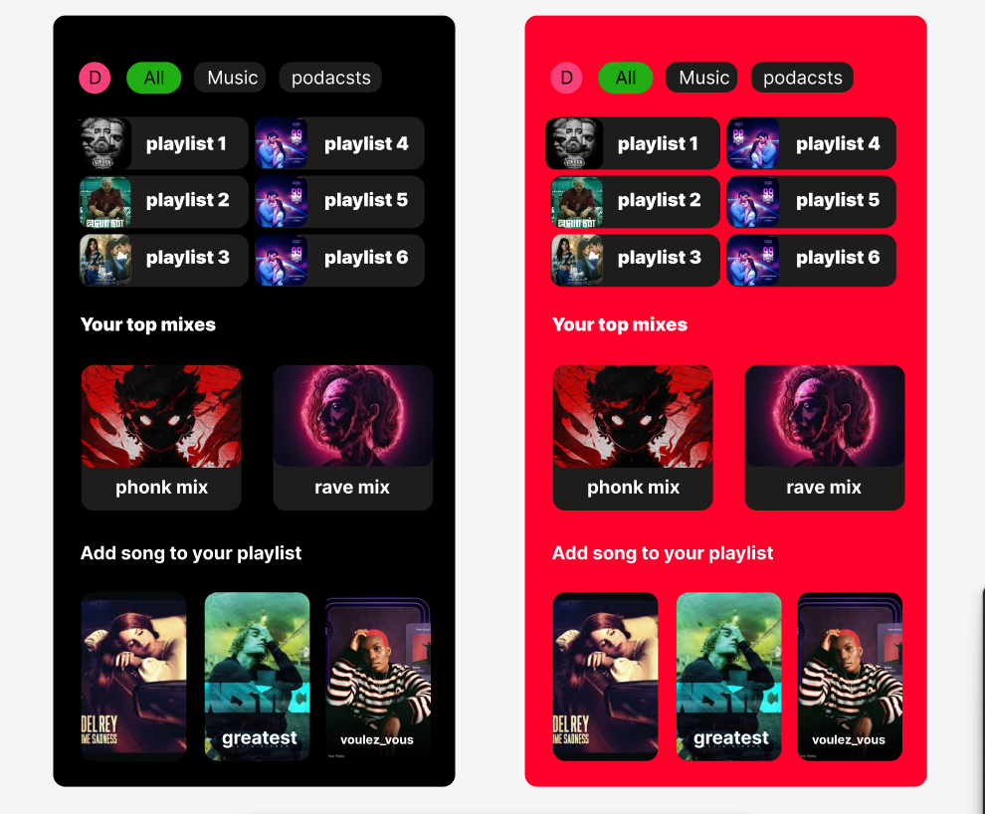

## RESULT

APP IS DESIGNED